Decoding Huffman codes

In 1952 David Huffman discovered an optimal compression algorithm for data. The algorithm assigns binary codes to items of data and generates a unique coding scheme based on that data. After transmittal, the binary code and its coding scheme are decoded to get back the original message. Today's zip files and .jpegs use variants of the Huffman compression scheme.

In this lab you will only decode a Huffman message. As an example, suppose the message is

010101111101111100000100110010011100

and its Huffman coding scheme is
<space> | 0110
M | 010
a | 0111
i | 10
p | 00
s | 11

Then the decoded message is:

___ ___ ___ ___ ___ ___ ___ ___ ___ ___ ___ ___ ___ ___ ___
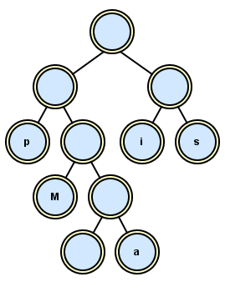
In this lab the scheme is a text file which you use to construct a binary tree. The zeroes and ones describe the path to get to the leaf, where a "0" means a left branch and a "1" means a right branch. The non-leaf nodes all store empty strings while each leaf stores the value of the letter as a string. The scheme above turns into a tree looking like this:

After the scheme builds the tree, the tree decodes the binary text. You follow the zeroes and ones until you reach a leaf, which stores the letter you want. As you can see for yourself, each path is unique, i.e., no letter’s code is a prefix of any other letter’s code.

Assignment
Write the program deHuffman that prompts the user to read two files, the binary message and the Huffman coding scheme. Then decode and output the message. At the beginning, decode the two files message.maips.txt and scheme.maips.txt and see if your tree is like the tree above. Then decode the other text files in the folder.

